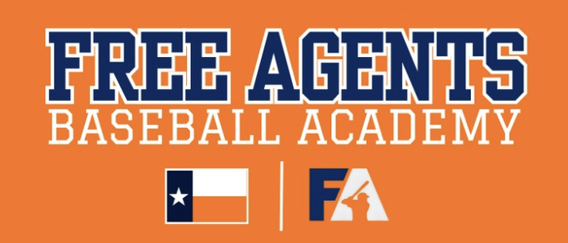
Thank you for your interest in supporting Free Agents Sports Academy 1st Annual Golf Tournament @ Bay Oaks Country Club. Please complete the form below and email back to liza_elliott@yahoo.com.
First Name _____________________ Last Name __________________________ Company/Organization _______________________________________________ Email ____________________________________Phone ___________________ Street Address ______________________________________________________ City / State / Zip _____________________________________________________ Sponsorship Level: __________________________________________________
☐ Payment via check (made payable to Free Agents Sports Academy)
☐ Payment via Zelle : #281-932-1697 /Free Agents Baseball - David Hyde.
Sponsorship Recognition
Name as it should be listed online: ______________________________________ Company weblink for recognition: ______________________________________
To appropriately recognize your businesses, please email liza_elliott@yahoo.com a copy of your logo so we may post on our social media platforms and print banners/ signage. Please have all company information and logos submitted before or by December 5th 2024

